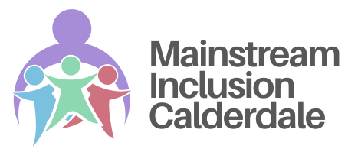

Provision that the local authority expects to ordinarily be made available for children and young people with special educational needs and/or disabilities in Calderdale schools, settings, and colleges.

Co-produced by Calderdale LA, health professionals, local settings, parents, carers and children and young people with SEND.

Contents | Page
Background and development | 2
Defining Special Educational Needs | 3
Guiding Principles | 4
Introducing Mainstream Inclusion Calderdale | 5
Section 1 Universal Provision | 5
Expectations for all settings | 6
The Calderdale SEND Review Toolkit | 7
The Calderdale SEND Database | 8
Section 2: Targeted Provision | 9
The Graduated Approach | 9
How to use the Guidance | 10
The Role of High-Quality Interventions | 12
Inclusive Language and the Use of Labels: Guidance for Educational Practice | 14
Appendices
Appendix 1 Universal expectations
Appendix 2 Overview of Targeted approaches
Appendix 3 Training materials
Appendix 4 Glossary of terms
Accessing Calderdale SEND Resources
Annex 1 – Calderdale SEND Review Tool
Annex 2 – Tailored Approaches: Speech, Communication and Language
Annex 3 – Tailored Approaches: Cognition and Learning
Annex 4 – Tailored Approaches: Social, Emotional and Mental Health
Annex 5 – Tailored Approaches: Physical and/or Sensory
To ensure you are using the most up-to-date versions, please access these resources directly through the Calderdale Local Offer

Background and Development
The SEND Code of Practice provides statutory guidance for the Special Educational Needs and Disabilities (SEND) system, covering children and young people aged 0–25. All local authorities and educational settings are required to have regard to this Code when making decisions about children and young people with SEND. Chapter 4 of the Code outlines the responsibility of local authorities to set out the provision they expect to be available across education settings for children and young people with SEND.
This includes guidance on:
- Approaches to teaching
- Adaptations to the curriculum and learning environment.
- Additional learning support

This document sets out the approach taken in Calderdale to promote inclusive practice in mainstream settings. It has been co-produced with a wide range of stakeholders, including:
- Children and young people with SEND
- Parents and carers
- Local education settings
- Health and SEND professionals.

The development process has involved:
- Working party groups made up of SENCos, teachers and senior leaders from Calderdale’s specialist, mainstream, primary, secondary, and post-16 settings.
- Regular feedback opportunities
- Parent Carer Forums
- Engagement with the Calderdale SEND Youth Council

We are hugely grateful for the valuable feedback and contributions received throughout this process.

Defining Special Educational Needs
The SEND Code of Practice (Section 6.15, 2015) defines special educational needs as follows:
“A child or young person has special educational needs if he or she has a learning difficulty or disability which calls for special educational provision.”
- A learning difficulty is defined as “a significantly greater difficulty in learning than the majority of others of the same age.”
- A disability is defined as a condition “which prevents or hinders him or her from making use of facilities of a kind generally provided for others of the same age.”

Purpose of the Guidance
Mainstream Inclusion Calderdale Guidance is intended to:
- Outline the provision and support that mainstream settings should be able to provide for all children and young people (including those with SEND) attending an educational setting in Calderdale within their notional inclusion budget.
- Help schools and settings consider what extra support might be relevant for children and young people who are not progressing at the rate they would expect.
- Help parents understand what schools will be doing.
In Calderdale, we take a needs-led approach to support. This means focusing on the unique profile of an individual’s strengths, skills, and needs, rather than relying on a formal diagnosis.

Terminology
Throughout this document, we use the following terms:
- Children and young people – refer to all children and young people (including those with SEND)
- SEND – refers to Special Educational Needs and/or Disabilities.
- Practitioners or Teachers – refers to adults supporting children and young people.
- Settings – refers to educational placements including schools, and colleges.

Please refer to the Glossary at the end of this document for a full guide to the terminology used.

Guiding Principles
These guiding principles underpin the Mainstream Inclusion Calderdale Framework. They shape everyday practice, promote consistency, and reflect our shared commitment to inclusive education. They are designed to support our schools in making inclusive, values-led decisions across all aspects of provision.
Ethical practice
Ethical practice means acting with integrity, transparency, and accountability, ensuring that the best interests of children young people and their families are at the centre of every action. All decisions should prioritise the rights, dignity, and well-being of all children and young people.
Growth mindset
We believe in the potential of every learner to progress, and flourish. A growth mindset approach focuses on strengths, celebrates effort, and provides opportunities that enable all children and young people to succeed. This mindset also extends to practitioners, fostering a culture of continuous learning and professional development.
Child-centred
Every child is unique, with their own strengths, aspirations, and challenges. Placing children and young people at the heart of decision-making ensures that their voices are heard, their identities respected, and their experiences valued. This means working with children, young people and their families, not just for them.
Evidence-informed
Practice should be guided by the best available research alongside professional expertise and the lived experiences of children, young people and families. By combining research, professional insight, and lived experience, settings can create provision that is both effective and responsive.

Introducing Mainstream Inclusion Calderdale (MIC)
Mainstream Inclusion Calderdale (MIC) is understood through a graduated approach that combines universal and targeted provision:
Section 1: Universal Provision  Whole School Approaches to Inclusion  A set of expectations that contribute to effective outcomes for all, including children and young people with SEND. | Section 2: Targeted Provision  Tailored Approaches and strategies that settings could ordinarily take to meet an individual child or young person’s needs. This section is organised to correspond with the four broad areas of need identified in the 2015 SEND Code of Practice.

Universal and Targeted Provision: A Continuum of Support

Universal provision strengthens inclusive practice across the whole school, ensuring that all pupils benefit from high-quality teaching and supportive environments. Targeted provision complements this by guiding the planning and review of support for individual children and young people with SEND.

Together, these approaches form a cohesive and responsive framework for embedding inclusive principles at both systemic and personalised levels. They create a continuum of support ensuring that every child or young person receives the right help, in the right way, at the right time.

Section 1 Universal Provision
Getting universal provision right for children and young people with SEND is not just best practice, it is a legal and moral obligation. Schools must comply with the SEND Code of Practice and equality legislation, which require reasonable adjustments and high-quality teaching for all pupils. Universal provision is a key part of meeting these statutory duties.
But its impact goes far beyond compliance. Universal provision removes barriers to learning for all, not just those with formal diagnoses. It fosters a culture of belonging, where diversity is valued and every learner feels included.
Strategies such as adaptive teaching, visual aids, and sensory-friendly environments help identify needs early, often before formal assessments are made. This early support can prevent challenges from escalating and reduce the need for more intensive interventions later.
Many approaches that support children and young people with SEND; like clear instructions, structured routines, and emotional regulation tools, benefit everyone. Schools that embed these strategies into everyday practice often see improvements in engagement, behaviour, and academic progress across the board.
When support is part of the daily classroom experience, it normalises difference and reduces stigma. This encourages peer acceptance and helps children and young people feel confident in seeking support when they need it.
Universal provision is also cost-effective. By reducing reliance on one-to-one support and specialist interventions, schools can allocate resources more strategically targeting support where it is most needed.
Expectations for all settings
In Calderdale, we have developed a clear set of expectations, organised into nine key sections (outlined in the table below).
Section | Expectations - Key Components of Inclusive Practice
Outcomes | Ensures children and young people with SEND make meaningful academic, social, and emotional progress.
Leadership | Highlights the role of school leaders in creating an inclusive culture. Emphasises strategic planning, inclusive ethos, and accountability.
Assessment & Early Identification | Promotes early and accurate identification of needs through observation, assessment, and collaboration with families and professionals, enabling timely, tailored support
Curriculum & High-Quality Teaching | Ensures an ambitious, accessible curriculum for all. High-quality teaching includes adaptive strategies, scaffolding, and responsive planning to meet diverse needs.
Environment | Considers physical, sensory, and emotional aspects of the learning environment to reduce barriers and promote engagement.
Pastoral | Supports emotional wellbeing, positive relationships, and behaviour through nurturing, consistent approaches.
Preparing for tomorrow | Equips children and young people for transitions and adulthood through life skills, independence, and future planning.
Voice of the Child and Family | Actively involves children and families in decision-making, recognising their insights and rights.
Staff skills and training | Ensures all staff have the knowledge, confidence, and ongoing professional development to meet SEND needs effectively.
A copy of these expectations can be found in Appendix 1.
Although the nine areas were developed locally for Calderdale, they are closely aligned with national, evidence-informed frameworks, particularly those promoted by the Education Endowment Foundation (EEF) and Whole School SEND. These expectations reflect the Teachers’ Standards and draw on approaches known to support positive outcomes for children and young people with SEND.

By drawing on these trusted sources, the nine-area framework bridges local priorities with national research. It offers a robust and coherent foundation for inclusive school provision, supporting both strategic planning and day-to-day practice.

The Calderdale SEND Review Toolkit
Achieving meaningful inclusion requires continuous effort, reflection, and adaptation to ensure that every child and young person feels valued and has equal access to opportunities. Therefore, to support settings in Calderdale, we have created the Calderdale SEND Review Toolkit ; a structured framework designed to help schools and settings reflect on current practice, celebrate strengths, and plan strategically for both short- and long-term improvements. Its ultimate aim is to enhance outcomes for children and young people with SEND.

Central to the self-review tool is a commitment to collaboration. It fosters ongoing dialogue between Headteachers, SENCos, governors, and senior leaders, while encouraging all staff to contribute to effective provision and improved outcomes for CYP.

The toolkit includes a range of evidence-gathering activities: interviews with parents, children, and practitioners; lesson observations; consultations with teachers and support staff to capture CYP views; sampling of current SEND support plans or Education, Health and Care Plans (EHCPs); and book scrutiny.

Settings in Calderdale will have free access to both a paper-based and an online version of the review tool. The digital platform also offers best practice recommendations aligned with the expectations, alongside a mechanism for evaluating SEND provision at the whole-school level.

Calderdale SEND Database

The Calderdale SEND Database is a curated, evidence-informed collection of tools, strategies, and examples of effective practice. It is designed to provide easy access to up-to-date research and approaches, supporting schools and settings to strengthen inclusive strategies and implement the graduated approach with confidence.

This flexible resource is shaped by partnership, developed collaboratively between schools and the Local Authority. It reflects real practice, evolving needs, and shared expertise across Calderdale. We welcome contributions, feedback, and examples from across our community.

Section 2: Targeted Provision
“Where a pupil is identified as having SEN, schools should take action to remove barriers to learning and put effective special educational provision in place.”
SEND Code of Practice 6.44

Targeted provision is additional and personalised support for pupils whose needs are not fully met through universal strategies alone. This may involve tailored teaching approaches, adapted resources in class, in specific areas such as communication, literacy, or emotional regulation or accessing small group evidence informed interventions.

This section provides tailored approaches and strategies that practitioners can use to meet the individual needs of children and young people with SEND. These are organised according to the four broad areas of need outlined in the 2015 SEND Code of Practice:
Cognition and learning  Strategies to support children and young people with difficulties in acquiring and applying knowledge and skills. | Communication and Interaction  Approaches for supporting those with speech, language, and social communication needs.
Social, emotional and mental health  Guidance for addressing emotional wellbeing, behaviour, and mental health challenges. | Sensory and/or Physical  Support for children and young people with physical disabilities, sensory impairments, or medical conditions.

The Graduated Approach

“This SEN support should take the form of a four-part cycle through which earlier decisions and actions are revisited, refined and revised with a growing understanding of the pupil’s needs and of what supports the pupil in making good progress and securing good outcomes. This is known as the graduated approach. It draws on more detailed approaches, more frequent review and more specialist expertise in successive cycles in order to match interventions to the SEN of children and young people.”

SEND Code of Practice 6.44

The Graduated approach involves a four-part cycle: Assess, Plan, Do, and Review. This approach emphasises early identification and intervention, with ongoing monitoring and adjustments to provision as needed.
Assess: This stage involves identifying a child's needs through observation, assessment, and gathering information from parents and other professionals.  Plan: A plan is developed to outline the specific support and provision required to address the identified needs.  Do: The planned provision is put into action, with the setting providing the necessary support and resources.  Review: The effectiveness of the provision is reviewed regularly, and the plan is adjusted as needed to ensure the child is making progress and achieving their goals. | 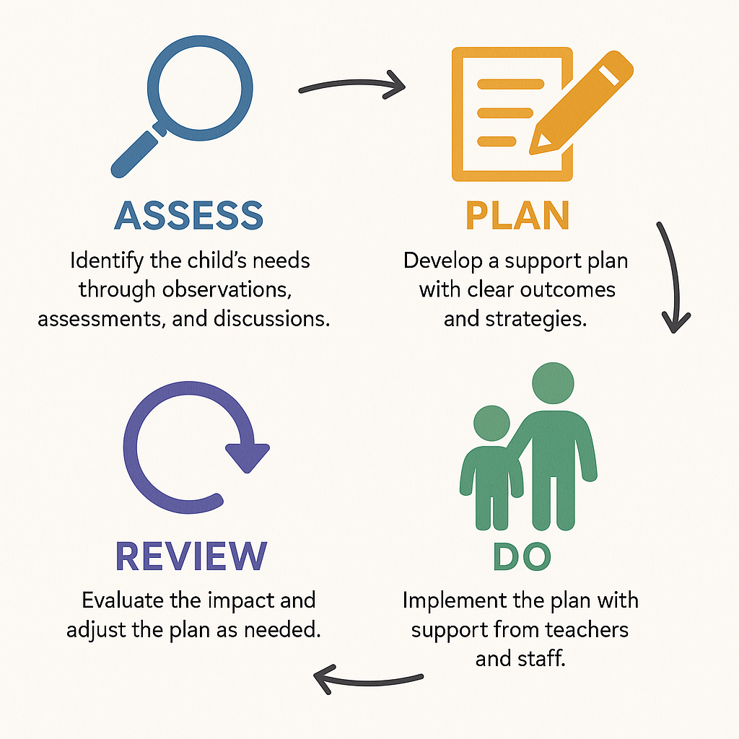

This cycle is repeated as with each review informing the next stage of assessment, planning, and action.

A note on using the guidance.
Every child or young person is a unique individual with distinct strengths, needs, and learning preferences. For educators, developing a deep understanding of each child or young person is essential to making informed decisions about provision, support, and strategies that enable meaningful progress.

This guidance organises strategies and resources into four broad areas of need. However, children and young people rarely fit neatly into these categories. Many experience overlapping needs, and their strengths and barriers may span multiple domains.

The categorisation within the database is intended as a navigational aid, not a rigid framework. While strategies have been grouped to support ease of use, they are not exclusive to any single area of need.
Professionals are encouraged to use the database flexibly, drawing on strategies across different areas to create tailored, responsive support. The most effective plans reflect the whole child, considering not only identified needs, but also their interests, strengths, relationships, and wider context.
By keeping each learner’s uniqueness at the centre, settings can ensure the resource serves its true purpose: to inspire and guide professional judgement, not to constrain it.
Reflective Questions
Use these prompts to guide planning, review, and collaborative decision-making:
- What are the child or young person’s strengths, interests, and aspirations?
How can these be harnessed to support engagement and progress?
- What specific barriers is the learner currently facing?
Consider academic, social, emotional, sensory, and environmental factors.
- How has universal provision (including high-quality teaching) supported the child or young person so far?
What has been effective, and where are gaps emerging?
- Which strategies or adjustments are most appropriate at this stage?
Are they evidence-informed, practical, and tailored to the learner’s profile?
- In what ways have the child/young person and their family contributed to planning and decision-making?
How are their views, experiences, and priorities reflected?
- How will the effectiveness of these strategies be monitored?
What indicators, observations, or data will be used?
- How will outcomes and progress be communicated?
Who needs to be informed, and what methods will ensure clarity and consistency (e.g., staff briefings, family meetings, shared documentation)?

The Role of High-Quality Interventions

High-quality adaptive teaching is our most powerful tool for securing pupil progress. However, some children and young people will require additional, targeted support to thrive. Carefully selected interventions, designed to complement, not replace, high-quality teaching can play a vital role in a school’s provision for pupils with SEND. These may focus on teaching specific skills, building emotional resilience, or addressing barriers to learning.

Supporting children and young people with SEND effectively requires a balanced approach that integrates:

Evidence-Based Practice (EBP): Interventions and strategies grounded in rigorous research and proven impact.

Practice-Based Evidence (PBE): Insights and adaptations developed through practitioner experience and contextual understanding. In effective practice, educators may develop or adapt strategies as a result of observation, ongoing monitoring, and reflective practice, tailoring their approaches to what works best for individual pupils in specific contexts. This approach is particularly important when working with children and young people whose needs do not align neatly with established interventions, and who may require more bespoke or flexible support.

By combining these two strands, educators can ensure that their support is both informed and adaptable, rooted in what works, and refined through reflective practice.

In each section of the guidance, we highlight carefully selected examples of evidence-based and evidence-informed interventions that have demonstrated impact in improving outcomes across areas of need. These are drawn from robust research and practitioner expertise, and the accompanying database signposts key messages distilled from current research (for example, insights into effective strategies for literacy, communication, and emotional regulation).

Ultimately, the key to supporting children and young people with Special Educational Needs (SEN) lies in the thoughtful monitoring, tailoring, and ongoing evaluation of interventions. Whether drawn from academic research or practitioner knowledge, interventions must remain responsive, effective, and aligned with the unique needs of each child. This dynamic approach ensures that support evolves as pupils’ needs change, and that provision remains both inclusive and impactful.

Prompts to Guide Intervention Planning and Review
These prompts support effective decision-making around interventions for pupils with SEND. They are designed to foster thoughtful planning, collaborative review, and impactful implementation:
- Use small group and one-to-one interventions with care
Less is more. Prioritise key outcomes and be clear about the intended impact. Avoid overloading pupils by focusing on what will make the greatest difference.
- Select high-quality, structured interventions
Choose interventions with a strong evidence base and clear structure. Refer to examples in our database to support informed selection.
- Adjust the intensity of support thoughtfully
Tailor delivery to pupil needs. This might include:
  - Slowing down to check understanding
  - Providing opportunities for independent practice
  - Supporting overlearning of key skills
  - Adding scaffolds or prompts where needed.
- Target the intervention closely to the identified need
Ensure the intervention addresses the specific barrier. For example, a reading intervention will be more effective if it targets the precise area of difficulty such as phonics, comprehension, or fluency.
- Implement Well and Sustain Gains
Effective implementation is key. Ensure:
- Practitioners are well-trained and confident.
- Pupil voice, family input, and teacher collaboration are valued.
- Gains are celebrated and embedded back into classroom practice.

Adapted from the Selecting interventions | EEF

Inclusive Language and the Use of Labels: Guidance for Educational Practice
It ain’t what they call you,  It’s what  YOU  answer to.  WC fields | Language is a powerful tool in shaping how children and young people see themselves and how they are seen by others. When used thoughtfully, it can affirm strengths, foster belonging, and guide meaningful support.
Why Language Matters
Thoughtful, strengths-based language affirms identity and potential, fosters self-worth and belonging, and enables personalised support. Without care, however, language can unintentionally emphasise deficits or medicalise difference, affecting a child’s self-perception and sense of worth.
Inclusive practice means listening to and honouring the language individuals and families use to describe their experiences. This fosters trust and ensures support feels personalised and respectful.
Principles for Inclusive Language
Balance Strengths and Needs  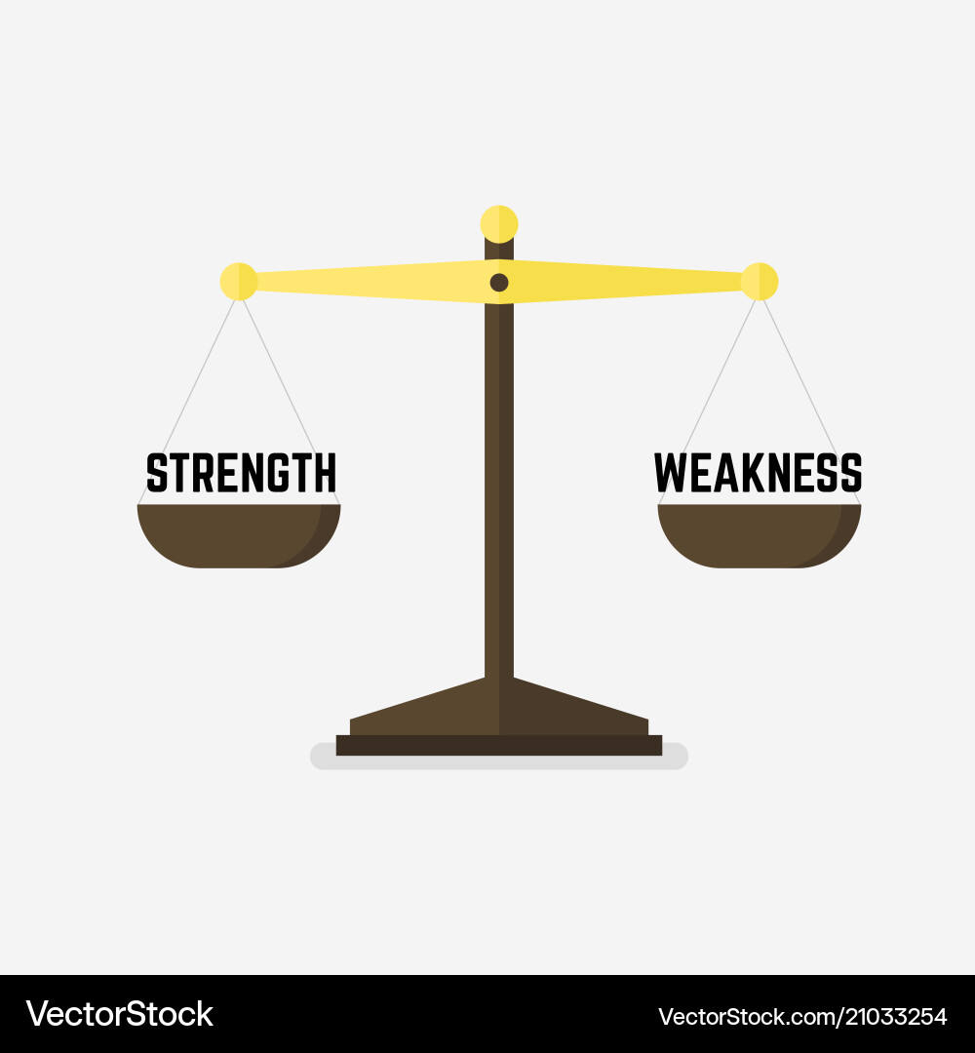 | - Describe both what a child finds challenging and what they excel in.  - Use neutral or strengths-based terms (e.g., “experiences difficulty with…” rather than “can’t…”).  - Avoid language that implies blame, limitation, or fixed ability.
Respect Personal Preferences   | Ask families and young people how they prefer their needs and strengths to be described.  - Honour cultural, linguistic, and identity-based preferences.  - Recognise that preferences may evolve over time.
Centre the Child’s Voice   | Uphold Article 12 of the UN Convention on the Rights of the Child: children have the right to express their views and have them taken seriously.  Create safe, supported opportunities for children and young people to share their aspirations, needs, and feedback.

Use Diagnostic Labels Thoughtfully
Diagnostic labels can play a useful role in helping individuals and families understand experiences and challenges. They may also support access to appropriate interventions and raise awareness among professionals, contributing to more informed planning and provision. When used carefully, labels can guide meaningful support and lead to improved outcomes for children and young people with SEND.

A Note of Caution
It is important to approach diagnostic labels with sensitivity. While they can offer clarity, labels may also carry unintended consequences. These include:
- Stigmatisation, which can lower an individual’s self-worth and sense of belonging.
- Deficit-focused thinking, where attention centres on what a child cannot do rather than their potential.
- Overgeneralisation, which may obscure a child’s unique characteristics, preferences, and learning styles.
- Reduced staff confidence, where practitioners feel less equipped to support needs perceived as complex or label dependent.

Diagnostic labels do not automatically lead to improved outcomes. Effective support should be informed by, but not reliant on, diagnosis. It is recommended that practitioners specify the particular areas of difficulty a child is experiencing, rather than relying solely on diagnostic categories.
Recommended Practice
Support should focus on the child or young person’s unique profile of strengths, skills, and needs. When shaping provision and outcomes, practitioners should consider a broad range of influencing factors, including:
- Environmental context and learning opportunities.
- Exposure to language and communication
- Emotional wellbeing and relationships
- Previous experiences of intervention
- The quality and consistency of support

By maintaining a holistic view and using diagnostic labels as one part of a wider understanding, practitioners can ensure that provision remains personalised, respectful, and responsive.

Appendix 1: Expectations for all settings

Note: these expectations are not intended to be seen as a checklist, but a set of good practice statements intended to be used by settings to evaluate inclusive mainstream practice. They have been compiled thanks to our Calderdale working group and are closely aligned with national, evidence-informed frameworks, particularly those promoted by the Education Endowment Foundation (EEF) and Whole School SEND.
Focus area: Outcomes | Teaching Standard 2: Promote good progress and outcomes
Our leaders are accountable for evidencing that children and young people with SEND make meaningful progress across the curriculum, with outcomes that reflect both academic achievement and personal development from their starting points.
Our leaders can demonstrate that children and young people with SEND make sustained and measurable progress across a broad curriculum, relative to their individual starting points, by the end of each key stage.
We regularly monitor the attendance of children and young people with SEND and take actions to improve it.
Children and young people with SEND are included in all aspects of school life including school trips, extra-curricular clubs.
We monitor suspensions and exclusions rate for children and young people with SEND regularly and, where appropriate, we adjust provision to ensure that learner needs are being met. There are no informal or unofficial exclusions.
We regularly monitor types and rates of patterns of bullying to help identify barriers to learning.
We ensure our safeguarding procedures ensure all children and young people (including children and young people with SEND) are kept safe.

Focus area: Leadership | Headteacher Standard 5: Additional & SEND Teaching Standard 2: Promote good progress & outcomes
Our leaders are driving improvements for pupils with SEND
Our leaders create a culture of high aspiration for pupils with SEND
Our leaders and governors are knowledgeable about SEND policy, practice & key legislation. We have effectively implemented the 2014 SEND reforms and the Equality Act (2010)
Our SENCo has QTS and holds the NASENCO/NPQ Qualification (or is working towards) level 7 within three years of their role.
Our SENCo works closely with our headteacher and senior leaders to develop a whole school response to pupils with SEND.
Our school development plan includes clear aims and outcomes for pupils with SEND. Key priorities are identified correctly.
We have a named governor with responsibility with SEND who has attended appropriate training and offers effective challenge and support to senior leaders

Focus area: Assessment & Early Identification | Teaching Standard 6. Make accurate and productive use of assessment
Our setting takes a holistic approach to early identification of need and assessment.
We adopt a regular cycle of the graduated approach (Assess, Plan, Do, Review) to ensure that children and young people with SEND are making progress.
We have expertise in place to manage examination arrangements (access arrangements).

Focus area: Curriculum & High-Quality Teaching | Teaching Standard 1. Set high expectations which inspire, motivate and challenge CYP.  Teaching Standard 2 Promote good progress
Our teachers set goals that stretch and challenge CYP of all backgrounds, abilities, and dispositions
Our teachers are responsible and accountable for the progress and development of children and young people in their class (including where children and young people access support from teaching assistants or specialist staff).
Our practitioners have a secure understanding of how a range of factors can inhibit children and young people’ ability to learn and how best to overcome them.
Our practitioners make adaptations and use evidence-based strategies known to be effective for all children and young people.

Focus area: Environment | Teaching Standard 5. Adapt teaching to respond to the strengths and needs of all CYP: have a secure understanding of how a range of factors can inhibit CYP’ ability to learn, and how best to overcome these
Our emotional environment promotes good wellbeing for all.
We routinely audit our physical environment to ensure it meets the needs of all children and young people.

Focus area: Planning for Tomorrow | Teaching Standard 1 Set high expectations which inspire, motivate and challenge CYP.  Teaching Standard 7 Manage behaviour effectively to ensure a good and safe learning environment
Our setting prepares children and young people for adulthood at all stages of learning
We actively plan for routine and life transitions.

Focus area: Voice of the child & family | Teaching Standard 8: communicate effectively with parents about CYP’ achievements and well-being.
We place high value on CYP and parent voice. This impacts on our practice and provision and celebrates achievement.
Every child and young person in our setting has the opportunity to be involved and heard.

Overview of Targeted approaches (organised according to the four broad area of need).
Cognition & learning | Communication & interaction
Social, Emotional & Mental Health | Physical and/or sensory
Cognition and learning Strands.
Aspect | Presenting Barriers & challenges
Reading | Reading Fluency Reading slowly and finding reading difficult and tiring  Comprehension: Child or young person has difficulties with understanding and interpreting texts.  Memory Child or young person finds it difficult to remember what they have read or frequently loses their place.  Dictionary Skills Child or young person finds it hard to use a dictionary, glossary, or index.  Visual processing: Child or young person finds black print on white paper difficult to see clearly.  Phonic decoding Child or young person is making limited progress in the school’s chosen systematic synthetic phonics programme.  Accessing whole class texts Child or young person has difficulties accessing whole class texts
Writing | Writing fluency Child or young person finds writing tiring or effortful/ organising ideas.  Spelling Child or young person makes frequent and inconsistent spelling errors.  Handwriting Child or young person has uneven/incorrect letter formation/illegible or difficult to decipher.  Thinking of what to say Child or young person has difficulties starting the task
Maths | Poorly developed number sense Difficulty understanding and working with numbers, including estimating, comparing quantities, and recognising numerical patterns.  Understanding mathematical vocabulary interpreting and using key terms and language specific to maths, which can hinder comprehension of instructions and problems.  Instant recall of facts ability to quickly retrieve basic maths facts (e.g. times tables, number bonds), affecting fluency and confidence in calculations.  Solving maths problems Challenges in applying reasoning and strategies to tackle unfamiliar or multi-step problems, often due to gaps in understanding or planning skills.  Maths anxiety lacking confidence in their own mathematical ability.  Literacy difficulties in maths learner’s literacy difficulties impacting upon access to maths lessons.
Executive Functioning | Flexibility of thinking / shift Adapting to change, transitioning between activities, and or revising plans when faced with new information, obstacles, or setbacks.  Emotional Regulation Recognising and or communicating feelings and managing these when experiencing strong emotions.  Response Inhibition Stopping and thinking before acting.  Sustained Attention Remaining focussed and on task in spite of distractions or lack of interest.  Task Initiation Beginning or starting a task.  Working Memory Holding information in mind whilst performing a complex task e.g. following multi-step instructions.  Planning and Prioritisation Creating a plan, make decisions and prioritising for task completion.  Time management Estimating and using time effectively. Difficulty keeping track of time.  Goal directed persistence Persevering, adapting and following a task through to completion.  Metacognition Stepping back to monitor and evaluate thinking and learning such as editing work.  Organisation of materials Maintaining systems for tracking information and having materials needed.  Stress tolerance Managing uncertainty, change and competing demands.

Communication & Interaction Strands
Aspect | Presenting Barriers & challenges
Speech, Communication & Language | Early Communication Looking, joint attention, taking turns and listening.  Attention and Listening: Processing and understanding spoken language in real-time, actively concentrating on auditory and visual stimuli in the environment.  Understanding of spoken language (receptive language): Comprehension of sentence structures, pronouns, negatives, plurals, tenses.  Expressive Language: the ability to express thoughts, needs, feelings, and ideas, use correct word order, grammar, plurals, tenses, etc.  Phonology speech sound production skills  Non-fluency/ stammering repeating words/sounds, stumbling, hesitating.  Quiet or reluctant speakers including selective or situational mutism
Autism  Social Understanding & Communication | Supporting access to lessons requiring imaginative thinking Engagement in activities that require imagination, flexible thinking, or creative problem-solving.  Communicating own needs Expressing needs, preferences, or discomfort  Social interactions Initiating, joining, or sustaining social interactions, participation in group work and peer relationships.  Understanding and expressing emotions Recognising, understanding, or expressing emotions, which can impact emotional regulation and communication with others.  Understanding the thoughts, feelings, and actions of others Interpreting or predicting the thoughts, feelings, or motivations of others  Friendships & relationships Forming and maintaining friendships and relationships
Autism  Flexibility, Information Processing & Understanding | Attention and listening- hyperfocus/monotropic attention (linked to SCLN)  Engagement in activities or lessons, especially if the content is not of personal interest or is perceived as irrelevant, leading to reduced participation.  Executive Functioning planning Including organizing, starting, and completing tasks, working memory and flexible thinking.  Changes & transitions Coping with changes in routine, environment, or expectations, leading to anxiety or distress during transitions between activities or settings.  Emotional understanding, regulation and self-advocacy Recognizing, understanding, and managing their own emotions, communicating emotional needs or advocating for themselves effectively.  Demand Avoidance Resistance or avoidance to everyday demands and requests impacting participation and cooperation.
Autism - Sensory Processing & Integration | Supporting children and young people to meet their sensory needs. Heightened or reduced sensitivity to sensory input (e.g., sounds, lights, textures), which can affect comfort, focus, and participation.

Social, Emotional and Mental Health Strands
Aspect | Presenting Barriers & challenges
Dysregulation | Managing or controlling emotions and behaviours, leading to outbursts, withdrawal, or unpredictable reactions.
Patterns of non-attendance | Regular or repeated absences from school or activities, which may be linked to anxiety, emotional distress, or difficulties coping with the school environment.
Emotional Wellbeing | Overall emotional health, including their ability to understand, express, and manage feelings, cope with challenges, and feel positive about themselves and their lives.
Making and Sustaining Healthy Relationships | The ability to form positive, trusting, and respectful connections with peers and adults, and to maintain these relationships over time.
Bereavement & Loss | Experiencing the death of someone close or other significant losses (e.g., family breakdown, moving home), which can deeply affect a CYP’s emotions and behaviour.
Trauma | Emotional or psychological harm from distressing events (e.g., abuse, neglect).
Physical symptoms (medically unexplained) | Physical complaints (like headaches or stomach aches) that do not have a clear medical cause, often linked to emotional distress or anxiety.
Attention difficulties | Challenges with focusing, staying on task, or being easily distracted, which can affect learning and behaviour
Safeguarding | Protecting CYP with SEND from harm, abuse, or neglect, and ensuring their safety and wellbeing in all settings.

Physical and/or sensory Strands
Aspect | Presenting Barriers & challenges
Children and young people who are deaf or have a hearing impairment | Accessing the classroom environment Environmental adjustments & adaptations  Access to the teacher & other children and young people in the lesson Ensuring practitioners understand the learner’s needs and apply inclusive strategies.  Friendships & social situations Support children in identifying their own wellbeing priorities.  Access to exams and assessments stay informed on best practices and legal requirements.  Auditory fatigue- due to the increased effort required for listening.  Executive functioning Deaf or hearing-impaired children and young people experience differences in executive functioning, creating obstacles in day-to-day life in a society that expects us to work a certain way such as meeting deadlines and perform tasks in a certain way.  Delayed literacy skills Advice on suitable adaptations for reading instruction.  Children and young people with a significant difference between their verbal (BSL) and written answers Advice on suitable adaptations  Frequent and inconsistent spelling errors Advice on suitable adaptations and effective strategies
Children and young people with a visual impairment | Access to classroom environment Environmental adjustments & adaptations  Moving around the setting Environmental adjustments & adaptations  Access to text Ensuring practitioners understand the learner’s needs and apply inclusive strategies.  Handwriting tasks Adaptations & effective instruction  Accessing Maths Resources adaptations and adjusted resources  IT lessons Adaptations & effective instruction  Access to interactive whiteboards  Access to practical lessons (DT, Science, Food Tech) adaptations and adjusted resources  Making friends and social situations Guidance and advice  Joining in PE & extra-curricular activities Inclusive sport and adaptations  Accessing Exams and Assessments Stay informed on best practices and legal requirements.  Independent dressing Strategies and guidance  Independence in eating Strategies, guidance and adapted resources  Independence in organising personal equipment Strategies, guidance and adapted resources
Sensory | Tasting (gustatory) differences Information and adjustments  Smelling (olfactory) differences Information and adjustments  Tactile (touch) differences Information and adjustments  Proprioceptive (sense of self-movement, force, and body position) differences Information and adjustments  Vestibular differences (the vestibular system helps maintain your sense of balance). Information and adjustments  Interoceptive differences (the internal sensory system that allows us to be aware of what is happening inside our bodies, such as feeling hunger, thirst, pain, or emotions like anxiety) Information and adjustments
Physical | Fine motor difficulties Assessment, adaptations and intervention  Gross motor difficulties Assessment, adaptations and intervention  Mobility Adaptations and guidance  Severe and complex medical needs including a life-threatening diagnosis or condition Guidance and advice
Glossary of terms
- Adaptations Changes made to the environment, curriculum, or teaching methods to support access and participation for pupils with diverse needs.
- BSL (British Sign Language) A visual language used by the Deaf community in the UK, with its own grammar and syntax distinct from spoken English.
- Equality Act (2010) UK legislation that protects individuals from discrimination and promotes equal opportunities, including specific provisions for disability and SEND.
- Fine Motor Skills involving small muscle movements, especially in the hands and fingers—important for tasks like writing, buttoning, or using scissors.
- Gross Motor Skills involving large muscle groups used for activities like walking, jumping, or climbing.
- Hyperfocus An intense form of concentration on a specific task or interest, often associated with neurodivergent profiles such as ADHD or autism.
- Mobility A pupil’s ability to move independently or with support, including walking, using mobility aids, or navigating the school environment.
- Monotropic Attention A tendency to focus deeply on one interest or activity at a time, often linked to autistic cognition and learning styles.
- NASENCO: National Award for SEN Coordination a mandatory qualification for SENCOs in England.
NPQ National Professional Qualification (a suite of leadership qualifications for educators, including NPQ for Leading Teacher Development or NPQ for Headship).
- QTS (Qualified Teacher Status)The professional status required to teach in state schools in England and Wales, awarded after completing initial teacher training.
- 2014 SEND Reforms Major changes introduced by the Children and Families Act 2014, including the creation of Education, Health and Care Plans (EHCPs) and a stronger emphasis on person-centred planning and outcomes.
- Sensory Integration The neurological process of organizing and interpreting sensory input from the body and environment to respond appropriately.
- Sensory Processing How the brain receives, interprets, and responds to sensory information. Differences in sensory processing can affect behaviour, learning, and comfort.

